**Silent Breaches, Loud Consequences: Consulting for Shadow Tech in the AI Era**

Author:- Parthiban G  
Ph.No:-9843777061  
email:-727823tuio035@skct.edu.in  
college:-Sri Krishna College Of Technology

Author:- Prem S  
Ph.No:-8778642535  
email:-727823tuio039@skct.edu.in  
college:-Sri Krishna College Of Technology

Author:- Pon Madhan D  
Ph.No:-9943244480  
email:-727823tuio039@skct.edu.in  
college:-Sri Krishna College Of Technology

**Abstract**

Rise of shadow ai, In the modern world , the gen ai tools like chatgpt,copilot,notion ai ,deepseek and bypassgpt etc…are now doing the humans works in an instant and makes our work simple.These tools help the people to create a more creative and work faster than humans.The difference between the intial days and modern days are that we don’t need any experience or to be expert to use these ai tools , you just need the internet access to start using these tools. But this became a pitfall and trap to growing with these ai . In the IT industry the employers are using the gen tools for their work to finish their job quickly without asking their project manager or head. This is known as an Shadow AI – when the peoples use ai tools secretly or without permissions from their team lead . The shadow AI becomes a common cause these ai tools are easy to use where it helps the people to do their work in an instant , but here it comes the risk . It might accidently share our data and the IT industry or companies might break privacy or security without knowning . More importantly business or project data could be leak or might be lost. These tools doesn’t always gonna give a exact or correct answers like( providing worng answers) may go unnoticed . The most scary part is, most of the Company Manager doesn’t know these tools are being used. It might cause hard to track problems or to stop them before they cause real trouble and damage.And this is all happening due to the (disruption in a tech) significant changes caused by new technologies and global conflicts already causing stress for business.The Shadow AI just include the one more risk that many companies and organization aren’t ready for. In some big industries like Samsong ,Amazon and JP Morgan already had an serious issue with employess for using ai tools in unsafe ways.Others have banned them entirely.But still most of the companies doesn’t have clear system to handle this growing problem. Here , this is where consultants come in . Traditional IT audits(where consultant check tech systems) aren’t enough anymore .To solve these issues we need an expert like , have to find hidden uses of ai in a company , have to check the risks and data problems , Setting up the system to watch and alert the upcoming future problems.More Importantly ,Set a clear rules for using ai safely. So here’s the idea ,this paper introduces a model called S.T.A.R.M. – (Shadow Tech Assessment and Risk Management) a guide to help the consultants to detect and manage the use of unauthorized AI in workplaces Learn how to control the gen AI tools-yeah! Ai tools are powerful and useful but if you used without control and safety it may also becomes a huge risk . So consultants need to help the companies (where in some companies thay had no idea to solve this issues) to find and fix these issues before they becomes a big problems.

**1. Introduction**

**1.1 The Rise of Shadow AI: A Side Effect of Easy-to-Use AI**

The AI tools like ChatGPT , Notion Ai , GrammarlyGO , Github Copilot and Midjourney had become very famous and easy for the peoples to use where doesn’t require any experience or skills.Nowadays peoples are using them to write essay,emails , create content,web page , design visuals and even write code . You don’t need to be an Tech expert anymore just an fair internet connection is enough . This trend is called as the Democratization of Ai ,which means these AI tools are available to everyone. While this has made work faster and easier , it has also started to create a hidden problem called Shadow AI . These problem will start happen when the employers use these Ai tools without telling or getting permission from their company’s or their team lead . Unlike older “Shadow IT” problems like using the unauthorized software or use of external cloud storage , Shadow AI operates operates through browsers and aloud APIs often with no installation required and it is hard to see . These tools often run in web browsers, so nothing gets installed or flagged by security systems. The Employers and workers might unknowningly enter private data, customer informations , legal drafts or source code into these AI tools. That info could be saved or shared or may be used to train future AI models . This means companies can lose control of sensitive information and have to be face legal problems or poor decisions based on incorrect AI-generated content. This problem could become even more dangerous than thought cause nowadays IT industries are already dealt with big challenges like global politics and fast changing technologies . In that pressure , using these AI tools may seem like a smart word and shortcut , but it’s lead to the serious consequences and big thread.

**1.2 The Hidden Risks: From Rule-Breaking to Real Damage**

At first , the big thread of Shadow AI might look harmless-just another tool to get the work done faster .But in reality , it creates serious risk that can damage a whole business. The one big issue is that it breaks the rules of data safety and responsibility . For example , if someone uses the deepseek or chatGPT to write a report to private company or client data , that the information might go to the servers outside of the country or third-party companies. This could cause to break privacy laws like GDPR (Europe) , HIPPA (US healthcare) , or India’s DPDP Act. It might raises legal question : who owns the information ?or Could it be hacked? Or Could it be used without permissions? There are still many problems ,one of them is that AI tools sometimes make things up called hallucinations. They will not provide exact or correct answers but confident answers. And if the users and employers trust this information and apply it in reports or business decisions , the results can be very harmful like wrong choice, bad advice and even lawsuits. Some of the tools may also use copyrighted material without permission or offensive content or putting companies at risk of legal and ethical trouble. These issue are great thread and problem in startups and fast-moving companies.These startups often don’t have any strict tech rules , so employees are encouraged to try new tools-but without any permission or guidanceon using AI safely. On the other hand ,the large companies already banned or may try to ban these tools like (JPMorgan or Amazon did ), but find it hard to stop them from using these tools . As the result? Companies end up with confusing rules, hidden uses of AI and blind spots in their security systems. Actually Most of the workers and employers don’t even realize they’re up to really something risky cause they’re not trained on what counts as unsafe AI use or what rules apply to tools like Notion Ai or image generators like DALL-E. So what feels like is just “getting help from a tools or AI” are actually put the entire company at risk.In the end , when Shadow Ai causes problems like leaking the informations and data or legal violations, the whole company will suffers, not just an individual persons issue who just used the tool.

**Fig. 1.** *Infographic: Shadow AI Risk Pyramid .Were generated by AI*

**1.3 Why Consultants Are Key: Making the Invisible Visible**

In this context, the role of consultants becomes crucial , as companies are race to adopt these AI tools, many don’t even realize the hidden risk they’re taking.Unfortunately ,they need a help to figuring out where the AI is being used in unsafe ways and that’s where the consultants come in. Consultants brings an outside perspective, which helps them to spot the things where the company’s internal teams actually might miss.They can explain technical issues in a way business leaders understand ad helps to build a smart policies to keep things safe and legal. Here’s what consultants can do like (Audit AI use) to find out which Ai tools employees are using without an approval and how often they’re using and also finds what kind of data iss being used.(Assess risk) after find out , rank those tools based on how risky they can be like (e.g., do they store your data? Are they based in another country? Also Do they follow local rules?) . (Suggest safer tools) Recommend approved tools along with strong data protection and (Train employee) Conduct an awareness to the compaigns and also a simple training to teach the staffs which is safer and what’s the risk lies in it while using AI . (Update rules) Write clear company policies for Ai use and built response plan just incase if something went wrong. This is especially important for the companies like startups which may not have their own legal or IT teams yet . So a consultant can help them to catch or notice a mistake in a early stage before they turn into a big legal problems.

**2. Shadow Tech – The Invisible Risk**

**2.1 From Shadow tech to Shadow AI: The Quiet Change**

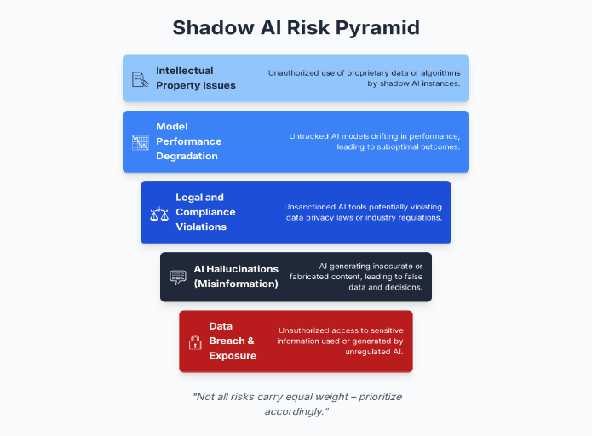In the past, companies had to dealt with the Shadow IT where the employees used the tools and services like Dropbox and whatsapp without permission .These tools were easy to track because they were installed or logged in , and IT teams could usually find them. But since 2022 , a new and difficult to detect the issues has appeared in the name of ‘Shadow IT’ . It happens when employees uses AI tools like ChatGPT , Bard, Notion AI ,Midjourney and others without telling the truth.These tools actually work in a web browsers or apps so they don’t need to be installed . This means they leave no clear trace , making them visible to most IT security systems. This trend is growing tremendously because AI tools are now easy to use and you don’t need to be an expert . For example , a marketing person use the chatgpt to write the posts and A legal intern can use AI to draft contacts and HR staff use the Notion AI to summarize the policies. These actions usually come from a good place people just want to be more productive , But often they won’t realize the risk it causing like sharing their private company data with the outside tools and breaking their data protection laws and they’re creating the content without checking if it’s accurate or ethical . These tools don’t leave audit trails like older software , which means the companies lose their control over what’s happening. It’s not just about using unapproved tools, it’s about sending sensitive company data to the unknown servers in othe countries.

**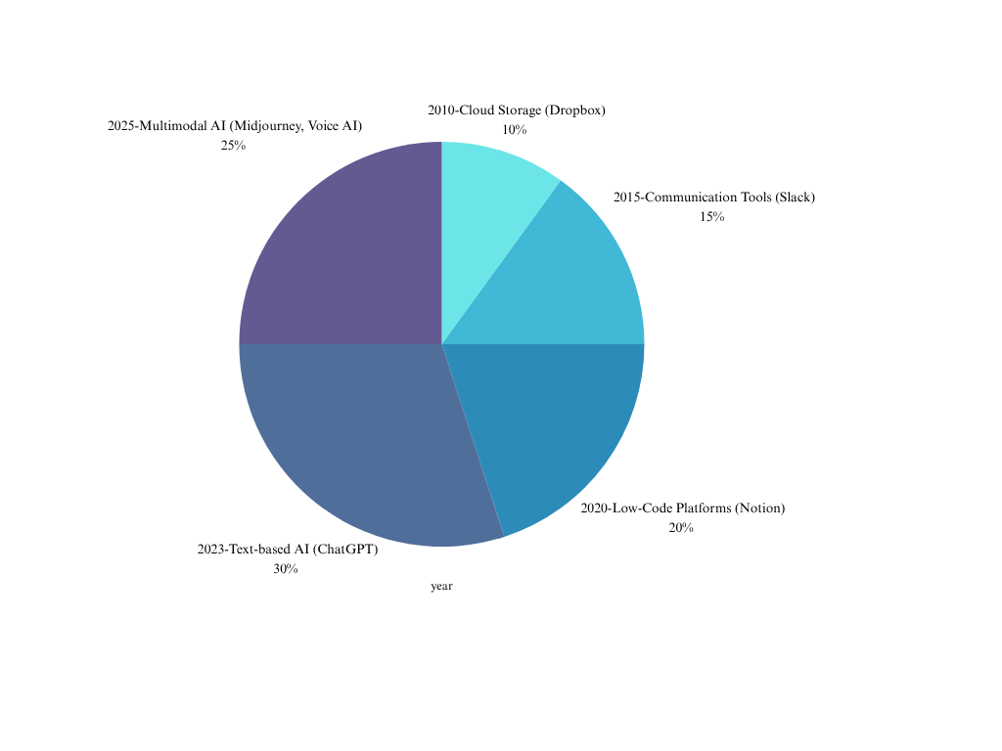  
Fig. 1.** *Timeline Chart: Evolution from Shadow IT ->Shadow AI*

**2.2 Hidden Hazards and Real-World Fallout**

Even though Shadow AI seems harmless , it’s already start causing real damage, here’s the real examples , (Samsung 2023) , Samsung engineers used chatgpt and try to fix the code but they accidently shared confidential project data. That datas were saved in OpenAI’s servers. This created a serious data breach and the company’s reputation suffered .(Amazon and JPMorgan) – Both companies has banned the ChatGPT because employees were using it to process the customer and financial data . Since they couldn’t control where the data was going , so they took the action to prevent the information. And possible Scenario : An EdTech Startup – just a small education company using Notion AI for creating the school guides . A intern paste all student data into the AI tool . The company grows and scales until a partner find this audit and reports it to a GDPR violation . As the result of these tools, Lost contracts , legal trouble , and a damaged reputation.In the contrary ,the other risks are copyright issues , A Marketing agency use AI tool called Midjourney to create the images . Later ,it turns out the images are so close to someone’s artwork . The agency could be sued. Blind Trust in AI’s – In 2023 , a lawyer in New York used the ChatGPT to write a legal document , it included a six fake court cases and it caused a scandal . Fake or Wrong Information (called hallucinations) it can lead to the bad business decisions and wrong reports or even dangerous medical advice if it’s not checked in the real source or proof .Every Ai tools aren’t risk or dangerous you just have to know which is unsafe to use , that’s why Shadow AI becomes risky because people blindly trust the information those AI’s provide so that’s becoming the output as risk when they don’t verify the content.

**2.3 Vulnerable Sectors and Magnified Risks**

Some of the industries are at higher risk from Shadow Ai cause they handles sensitive data or face strict rules. Using AI to process the confidential data could break the laws like those are from SEBI , the SEC , or MiFID ll. For example , A financial analyst shares a confidential market report with the ChatGPT – that’s the data leak . (HealthCare) – Patient records will be protected under the HIPPA laws . Doctor using the AI tool to write the patient summaries , here’s it might accidently share private health information with Outside AI’s platforms. Education Technology(EdTech) , Student information is often private , especially for minors . If tools like ChatGPT used carelessly can violate laws like COPPA (U.S) or DPDPA (India law). Startups , It often move fast and skip detailed tech policies . If single mistake is done by the employee with Ai tools could scare away investors or hurt the brand. The user’s information and customer’s information are very valuable but easily misused. Other High risk sectors, (Legal) Using the Ai tools to summarize the client material could break confidentiality . (Media) , AI tools could easily provide false information or biased content . (Defense) ,Sharing internal communication through AI tools could cause a national security risks. (Government), If public officials use any AI tools without the permissions , citizen datas or policy drafts could be exposed

**3. Real-World Cases and Impact**

**3.1 High-Stakes Exposure: Samsung's ChatGPT Leak**

The Samsung was the first company to face the horrible truth about Shadow Tech. Which it was happened in March 2023.Where the employees in Samsung company expecially in semiconductor division ,they were said that using ChatGpt to write technical documents and to correct code. In the process they accidentally given their private and proprietary info, like source code and chip architecture, through the AI platform. OpenAI processed and stored this data, which then lost from the secure walls of Samsung's internal network and entered third-party infrastructure that is subject to the foreign data policies. The consequences were not be just hypothetical; they reflected an immediate breach of intellectual property, a violation of internal compliance policies, and a stark realization of the uncharted legal space surrounding AI tools. While OpenAI claims that it does not use data submitted via ChatGPT API for training purposes, the default free versions available to users were not bound by such terms at that time. This ambiguity opened a potential loophole where company secrets could be absorbed, stored, or regurgitated in future AI outputs. Samsung responded swiftly by banning the use of generative AI tools across departments. They also implemented staff training on AI tool limitations and started an internal investigation. But in the era of Shadow AI, a single unauthorized query can compromise decades of research and development and cost billions of dollars in competitive advantage. This precedent was set by the reputational harm and internal strife.

**3.2 Proactive Caution: Amazon and JPMorgan’s AI Bans**

The companies like Amazon and JPMorgan took more proactive type of approach but Samsung's experience they have was reactive compared to that companies. That both organizations will provide early notice to the workers to not use the ChatGPT and similar tools in the work because using that AI without rules may cause possible dangers of losing companies data. Amazon told that they were worried about the sensitive code and customer data being made public. These choices are not only just keeping the data safe, They were also a lot of AI based on a deeper understanding of the risks the AI tools pose in the highly regulated areas. These types of cases are important because they happened in spite of AI's promise of increased in productivity. Employees found that chatGPT was useful for writing code snippets, creating summaries, and drafting emails. However, the failure to see how, where and why the data was being processed exceeded these advantages. These business has been chose to be cautious in the highly secured banking and e-commerce sectors. They were also started to speak about that the Coming of AI's potential are needed or else protect themselves from its unpredictability. Their restriction highlighted a great weakness in AI framework and indicated the increasing demand for the compliance tools especially designed for AI.

**3.3 The Hypothetical Startup Crisis**

Look at the EdTech startup named EduSpark, which has been recently become popular for its unique educational dashboards provided by them. The company makes use of a small number of people and encourages experimentation provided in their specialized category. Usually, it makes a use of generative AI technologies to produce the  internal documents, product mockups, and content rapidly. Having no idea about the consequences for law, the content team begins entering into private but sensitive student performance data into ChatGPT in order to generate automated report summaries frequently. Meanwhile, the UI/UX designer uses the Midjourney to create visual content without being aware of that the AI-generated photo or artwork may violate the copyright problem. Initially, the company observes a great decrease in turnaround times and there was an increase in productivity of that company. However, a global school chain discovers that their data handling processes are not up to a level in before after conducting a partnership audit.According to that audit, the student data was processed by the  third-party AI systems without any agreements to protect it or the students' knowledge.In addition, some AI-generated marketing designs appear to be very similar to copyrighted works , which is to be result in EduSpark facing legal action for intellectual property.There were Major consequences for the startup include losing important contracts, facing accountability under the GDPR and India's DPDPA, and affecting its reputation among other companies. Within some weeks, investors cancel, and the brand's value goes to zero. This fake example shows that the Shadow Tech is not only a possible problem in the future; it is a real one and present threat, especially for small and medium-sized businesses and the startups that don't have a proper governance structures.It also makes clear that the damage isn't just technological; it's also moral, legal, financial, and even existential issues.

**3.4 Compounding Consequences: Financial, Legal, and Reputational Fallout**

In all the three cases, there were some common patterns in this. When companies break their rules,then they have to pay fines, court settlements, and they lose investors. For example, breaking the GDPR rules can be cost you up to €20 million or 4% of your company's annual global sales. Companies could be face law by clients, customers, or content creators whose data or intellectual property rights were accidentally violated by the AI tools. Companies have to deal with the backlash from the stakeholders who want responsible AI use, which is the right thing to do. The shares which are more high when it comes to the recognition. In today's markets that the value are openness, even a hint of AI misuse can lead permanent hurt to the brand's reputations. It's hard to get back that trust once you've lost it, were especially in areas like finance, healthcare, and education where the customers expect more privacy and accountability. The long-term effects of this Shadow Tech activities are not just about the losing of money in right away; they are also about to losing the future opportunities.

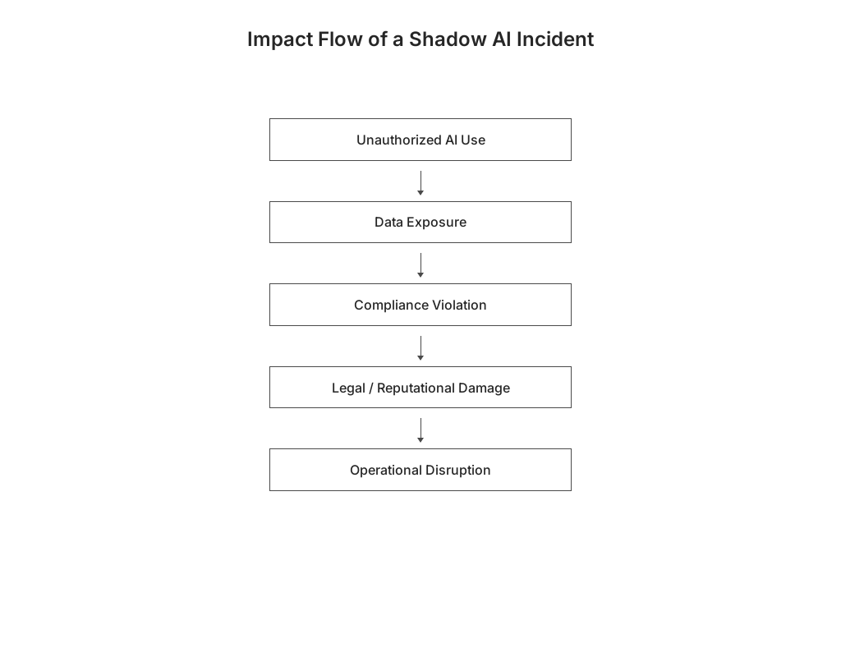

**Fig. 1.** *Flowchart: Flow of a Shadow AI Incident*

**4. The Role of Consultants in Shadow Tech Mitigation**

**4.1 Bridging the Gap Between Technology and Policy**

Shadow Tech, and specifically Shadow AI, is a new problem that comes up at the crossroads of technology, company culture, and rules.Consultants are very important in closing this gap because they will help businesses to understand that not only the risks that come with the new technology, but also the legal and moral issues will come with it.Because there are not many formal IT governance structures in place,the employees at many companies, especially startups and small and medium-sized businesses, often use the AI tools without the  permission or guidance. This independent use will makes everything less secure, which employees may not notice. Consultants can help you to see these blind spots by taking in an outside point of view and combining their knowledge of risk management, compliance, and technology strategy.Their first job is to explain complex about the AI risks to business executives and other stakeholders in terms they can understand. A lot of the time, it means demonstrating how Shadow AI can put brings businesses at risk of data gets out, IP theft, or regulatory penalties that may drive these individuals out of business.Because many businesses still have a view in AI as a means of increasing productivity rather than as a governance issue, this framing is crucial.

**4.2 Conducting AI Risk Audits and Shadow Tech Mapping**

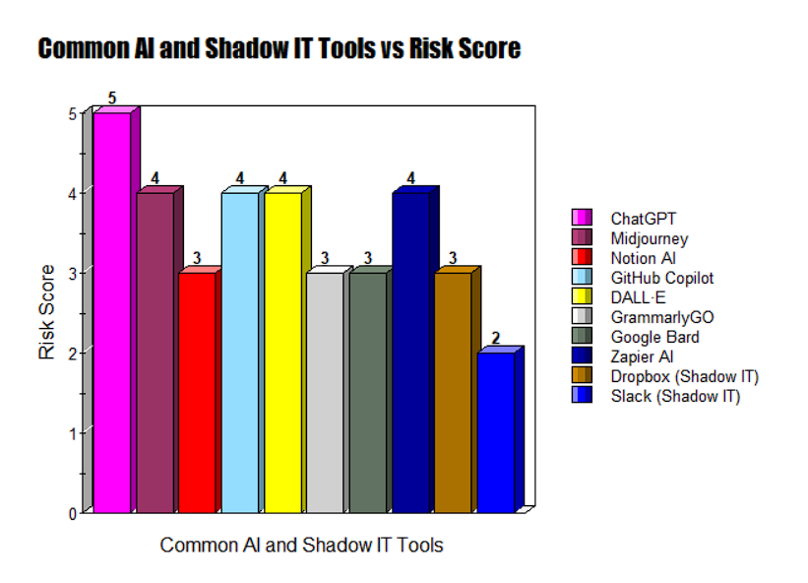Consultants  can may lower the risks related to the Shadow Tech by performing through the AI riskable audits. These audits will look at the particular shortcomings in the  AI technologies and their applications, going beyond the routine IT evaluations. The Consultants will work with IT, legal, and operational teams to find out whether the AI technologies are being used continuously, how the employees are using them, and what private data might be in jeopardy. This Activity, sometimes known as "Shadow Tech mapping," aids businesses in knowing the full scope of unapproved technology use. For example, mapping may can reveal that the even with ChatGPT's official prohibition, staff members are still using it informally to write the code snippets or client emails using that AI Technology. Similarly, marketing departments may can use AI-generated images without ensuring that they result in with copyright laws.Consultants may assess the  risk of exposure and pinpoint the areas were that need urgent attention thanks to these insights. In case to find the weaknesses in the AI governance and compliance of frameworks, this phase also may comprises examining existing with contracts, policies, and data flows.

**Fig. 1.** *Heat Map or Bar Graph:Common AI Tools vs Risk Score*

**4.3 Developing AI Ethics Policies and Governance Frameworks**

After the identification of risks attained, consultants were collaborate with the  organizations to create a big governance frameworks and AI ethics policies that will offer specific guidance for the application of AI usage. These regulations cover a vast range of topics, including the Types of AI tools that are permitted to use, the processing of data, data privacy duties, legal security measuresare taken, and procedures for reporting the  improper use of AI. Crucially,the regulations are made to hit  a balance between security and the innovation, understanding that too strict requirements may promote the use of the AI in more secret methods. Consultants will frequently suggest placing established AI governance committees or identifying AI governance officers to monitor respect to rules of the ethics. They will ensure that the company remains in the line with changing legal requirements that will be influencing the path of AI rules, like the EU AI Act or India's DPDP Bill.In order to prevent this adding third-party risks, governance frameworks may be also include to vendor the assessments and need to investigation before gaining AI tools.

**4.4 Employee Training and Awareness Programs**

Any of the Shadow Tech coping strategy's success depends on changing the employee's behavior and raising the knowledge. The development and execution of this  particular training courses that will inform the staff members about the risks of using AI technology without permission as well as the organization's policies is managed by consultants. These initiatives will promote the responsible AI adoption by demonstrating possible outcomes with real-world examples. The Role and function-based training is common to all; for example, marketing teams will  learn about the risks to property rights in AI-generated content, while developers receive the full guidance on secure methods for coding with AI assistance. Additionally, consultants build an environment of transparency that they encourages staff members to report the accidental security breaches or ask for any authorized AI tools, which simplifies the motivation for hidden use. Since their work teams and fast-paced environments have  often lack in official governance structures, startups and high-growth companies are greatly profit from this awareness-building. In order to ensure that the scalable and sustainable growth, consultants help these companies in combining AI risk management into their main business activities at an early stage.

**5. Proposed Consulting Model: STARM (Shadow Tech Assessment & Risk Management)**

**5.1 Overview of the STARM Framework**

This paper will suggests the STARM model: Shadow Tech Assessment & Risk Management as a systematic approach to handle the Shadow Tech risks. The STARM framework was created to be utilized by organizations to navigating the AI-driven the breakdown era as a continuous and periodic consulting approach. It offers an organized method that the consultants can able to use to identify, reduce control, and keep an eye on the Shadow Tech in a way that the follows with legal requirements and the business goals. The model's primary strength is its comprehensiveness, which will combines the ongoing governance, strategic advice, and technical scanning. Companies may switch from active patchwork responses to the active and integrated AI risk management through putting them STARM into the routine.

**5.2 S – Scan the Digital Environment**

To find the Shadow Tech, the STARM model's first step is to entails an extensive examination of the company's digital environment. This can also involves using of modern discovery AI tools that will keep an eye on this outcomes, network trafficking, and cloud usage to identify the unapproved AI apps, SaaS products, and extensions are in use. In order to implement this automated scanning technologies in addition to manual audits like the surveys and the interviews, the consultants collaborate together closely with the IT departments. In order to determine that what types of data are being feeded into the AI tools and where any possible leaks may occur, this scanning also contains shadow data flows. High-risk areas are like the sharing of trade secrets, regulated data, or personally identifiable information (PII) are  about the customers were founded through the scan. Crucially, this stage establishes the basis for a risk assessment that is fact-based rather than the assumption

**5.3 T – Track Unapproved Tools and Risk Vectors**

When the scope of the Shadow Tech have been identified by the first scan, then the  next step is to do monitor and  then catalog these unauthorized tools and the risk carriers were they are connected with. The Consultants can classify the tools based on their risk profile analysis, which includes whether they can able to handle sensitive data, produce outputs that definitely causes issues with the regulation, or to have confusing storage of data guidelines. This kind of classify to helps by  prioritize the reduction efforts. In addition, the tracking is one of the  dynamic since the tools are updated, user behavior varies frequently, and new AI applications are released daily. The Consultants create techniques and the dashboards that can provide up-to-date information on emerging dangers and trends in the application of AI tools. This  will continuous monitoring will enables organizations to maintain a high risk profile and adapt rapidly to other new threats.

**5.4 A – Advise on Mitigation Strategy and Tools**

Once the consultants have a great depth in understanding of the Shadow Tech environment, they can able to advise organizations on a specific mitigation strategies. This means that creating a filled AI toolkit for employees and indicating authorized AI solutions to that have been reviewed for ethical, legal, and safety concerns. In order to a successfully and safely integrating AI, consultants will help to rework processes, which reduces the need for the  employees to use the  unapproved AI tools. Another component of mitigation strategies involves setting in the place of technical controls, like encryption, user access management, and data loss prevention (DLP) systems, that will avoid the flow of the confidential information into the unapproved platforms or Websites. The Consultants also help in legal teams to create deals with suppliers with  that account for risks particular to AI. To maintain the organizations' flexibility and protect them from mistakes and consequences from the government, in this advisory step provide a balance between the innovation and risks.

**5.5 R – Regulate Usage with AI Governance Policies**

Official control of the implementation of AI technology through the broad governance policies are highlighted in the fourth step of the STARM framework. The Consultants will assist in creating clear, legally binding rules that can specify how the  AI tools, data processing, security for privacy, and the accountability procedures can be applied. These rules already align with existing IT governance, the compliance standards, and a new AI rules. Another essential component for effective regulation is the creation of devices for policy enforcement, such as compliance reviews, automatic alerts for policy violations, and giving penalties for unauthorized AI use. Consultants will help to integrate these governance activities into organizational culture through the leadership of support and continuous communication. Maintaining usage ensures that the Shadow Tech risks are taken handled by systematically instead of that the random of single employees.  
  
**5.6 M – Monitor Continuously with Compliance Checks**

The last stage of the STARM model, where continuous monitoring, ensures continuous compliance and the adaptation. The Consultants create key performance indicators (KPIs) and a risk measures to evaluate the governance framework's efficiency. This will includes the routine of compliance reviews, scenario-based examinations that will clone the Shadow Tech events and hacking tests. Another part of this monitoring is remaining up to date with new developments in the AI technology, changes in regulations, and in best practices. The Consultants provide more advice on how to appropriately handle the update policies and the controls to keep the organizations flexible in a rapidly changing environment. Because the repeated loop that the STARM builds, organizations are seeing Shadow Tech mitigation as a one of the crucial part of their strategic risk management instead of the temporary solution.

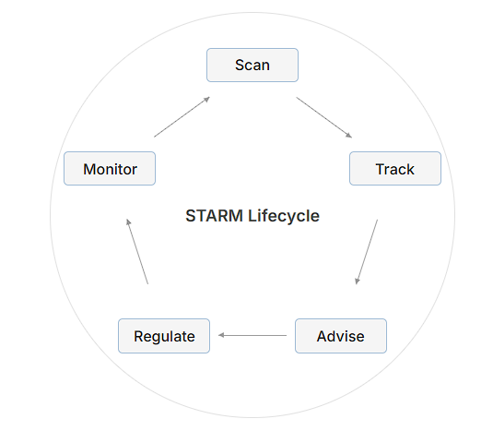  
**Fig. 1.** *Cycle Diagram: STARM Consulting Model. Were generated by AI*

**6. Future Outlook: Ethical AI Use and Consulting**

**6.1 Escalating Complexity of Shadow AI**

As artificial intelligence innovations gotten to be more implanted in working environment foundation and representative workflows, the complexity of checking and directing AI utilization increments drastically. Shadow AI is not  limiting to be text based associates with like ChatGPT; it presently includes the picture generators, code auto completers, synthesize video, and specific domain SaaS AI devices. This differences makes following Shadow Tech not as it were a specialized challenge but moreover an organizational and moral one. What’s especially concerning is the quick pace at which AI capabilities are evolving—outstripping the capacity of most inner IT groups to screen utilization in genuine time. This advancing risk scene suggests that organizations must move from detached approach systems to dynamic, responsive administration models. Conventional perimeter-based security is inadequately in a world where AI instruments are browser-accessible, cloud-hosted, and employee-driven. Devices may be utilized off the VPN, by means of individual gadgets, or exterior official channels, rendering ordinary information misfortune anticipation apparatuses out of date in numerous cases. Within the close future, Shadow AI will not be the special case but the default unless proactive techniques are actualized.  
  
**6.2 Rise of Global AI Regulation and Its Implications**

Recognizing these dangers, governments and worldwide administrative bodies are starting to require firm steps toward characterizing legitimate systems for AI administration. The European Union's Artificial Intelligence Act is one of the foremost comprehensive and forceful administrative systems created so distant. This classify the AI applications into the level based on hazard and requests that will keep up the businesses straightforward, auditability, and compliance all through the lifecycle of AI. Violations may applicable in punishments comparable in scale to GDPR—up to 6% of worldwide yearly turnover. The act does not simply influence European companies; any substance doing commerce with or handling information of EU citizens must comply. In India, the Digital Personal Data Protection (DPDP) Act signals a parallel accentuation on responsibility in information practices. The Act orders that any frame of information exchange, counting preparing by means of AI instruments, must happen beneath strict client assent and assurance standards. For a nation facilitating millions of data-centric new companies, this implies that unauthorized utilize of third-party AI stages seem lead to criminal risk. As more nations present AI-specific regulations—from the Joined together States' Official Orders on AI security to Canada’s Manufactured Insights and Information Act (AIDA)—the worldwide commerce scene will see rising request for cross-border compliance. This move requires organizations to insert compliance into the plan and utilize of each AI instrument, making it a center trade work instead of a legitimate afterthought.

**6.3 Consultants as AI Governance Specialists**

The joining of direction, morals, and developing innovation makes a unused category of ability that specialists are extraordinarily situated to fill: AI Administration Masters. These experts are not fair arrangement journalists or auditors—they are intrigue specialists competent of interpreting enactment into commonsense shields, adjusting corporate approaches to reflect moral AI standards, and actualizing administration components that advance with innovation. Within the coming a long time, we'll witness counseling firms—especially those with a center on computerized transformation—creating committed AI Administration Divisions. These groups will not as it were react to client occurrences but moreover expect them by conducting prescient reviews, making AI utilization warm maps, and building up early caution frameworks for Shadow AI. Administration experts will moreover play a major part in planning AI Morals Sheets inside organizations, guaranteeing progressing arrangement with industry best hones, societal desires, and the law. The rise of moral counseling in AI will too lead to the improvement of industry-specific AI measures. Fair as ISO guidelines oversee quality and security in fabricating, AI-specific certifications will develop, driven by experts, think tanks, and standardization bodies working in collaboration.

**6.4 Trade Basic: Morals as a Competitive Advantage**

Past direction and compliance, moral AI utilize is balanced to gotten to be a competitive differentiator within the commercial center. Shoppers and undertaking clients alike are starting to scrutinize how organizations utilize their information, prepare their AI, and guarantee non-discriminatory results. Speculators are appearing expanded intrigued in Natural, Social, and Administration (ESG) measurements, where dependable AI hones are likely to ended up a key sub-category. Moral straightforwardness will impact brand notoriety, client dependability, and accomplice believe. Firms that proactively contribute in dependable AI—demonstrating inside controls, review trails, and logical AI practices—will be favored in acquirement choices and open contracts. Counseling firms that empower such situating will not as it were offer assistance clients maintain a strategic distance from chance but too open long-term esteem. In this future, AI morals counseling won’t fair ensure the enterprise—it will characterize its vital personality.

**7. Conclusion**

**7.1 From Risk Awareness to Risk Leadership**

The rise of Shadow Tech, especially within the frame of Shadow AI, marks a turning point in how organizations approach computerized change. No longer is AI selection basically around automation or efficiency—it presently includes a genuine figuring with the moral, legitimate, and reputational dangers that can emerge from unchecked utilization. From Samsung’s incidental information exposure to speculative startup collapses due to poor administration, the message is evident: Shadow AI is genuine, show, and strong in its results. In this setting, organizations must move from simply recognizing dangers to effectively driving moderation endeavors. Shadow Tech must be recognized not as a negligible issue, but as a center portion of advanced hazard administration. This alter requires key oversight, clear systems, and cross-functional collaboration—an biological system that cannot flourish without master direction. And this can be where the counseling industry has an crucial part.

**7.2 The Counseling Command: Ethical AI by Design**

As illustrated all through this consider, specialists are not fair eyewitnesses of the Shadow Tech phenomenon—they are basic on-screen characters in containing and changing it. With their vantage point over businesses, geographies, and administrative scenes, specialists have the bits of knowledge and apparatuses required to analyze imperceptible dangers and actualize maintainable countermeasures. Their part incorporates not as it were making arrangements but too changing organizational mindsets through preparing, administration structures, and social shifts. The STARM demonstrate presented in this research—Scan, Track, Advise, Regulate, Monitor—provides a organized, versatile strategy that experts can apply over differing trade settings. It equalizations location and avoidance, procedure and execution, specialized knowledge and moral prescience. Most imperatively, it strengthens the thought that Shadow Tech isn't a purely technical challenge—it could be a administration basic. Through STARM, experts can provide quantifiable affect, making AI biological systems that are inventive, compliant, and trusted.

**7.3 Making the Invisible Visible**

In conclusion, as AI proceeds to coordinated into our proficient and individual lives, the shadows it casts develop longer and more complex. Shadow Tech is now not a covered up anomaly—it is an developing standard driven by democratized get to and decentralized decision-making. Organizations that come up short to recognize its impression are not fair gambling administrative penalties—they are undermining their possess versatility and reliability.

**8. References**

* European Parliament. (2024). *Artificial Intelligence Act*. Retrieved from <https://eur-lex.europa.eu>
* Government of India. (2023). *Digital Personal Data Protection Act*. Retrieved from <https://www.meity.gov.in>
* McKinsey & Company. (2023). *The State of AI in 2023: Generative AI’s Breakout Year*. Retrieved from <https://www.mckinsey.com>
* World Economic Forum. (2022). *Responsible AI: Global Frameworks and Practical Implementation*. Retrieved from <https://www.weforum.org>
* OpenAI. (2023). *How ChatGPT Uses Your Data*. Retrieved from <https://help.openai.com>
* Reuters. (2023, April 10). *Samsung bans ChatGPT use after data leak*. Retrieved from <https://www.reuters.com>
* Financial Times. (2023, May 2). *Amazon restricts ChatGPT use amid data concerns*. Retrieved from <https://www.ft.com>
* Harvard Business Review. (2023). *Shadow AI: The Hidden Risk Lurking in Your Workplace*. Retrieved from <https://hbr.org>